Bushmen versus Waldron
Sunday 21st May 2017
Time game
Toss: Bushmen who fielded

Waldron
- H Keenlyside c M Jackson b H Owens 11
- F Elliott c D Morley b H Khan 14
- P Nandanapam c M Jackson b H Khan 19
- C Butcher c D Morley b H Khan 26
- D Majitha b P Assegai 2
- P Phair b P Assegai 9
- W Muschialli c H Owens b H Khan 12
- A Randall not out 50
- N Foster lbw b H Owens 7
- M Illingworth not out 5
- A Durrant did not bat
Extras (nb0, w8, b3, lb3) 14
TOTAL (39 overs) 172 for 8 declared
1-25, 2-33, 3-56, 4-71, 5-80, 6-93, 7-114, 8-141
O M R W
- H Owens 10 2 49 2
- C Jeavons 5 2 10 0
- P Assegai 14 0 67 2
- H Khan 10 2 35 4

Bushmen
- J Whitehead b Butcher 12
- W Cockerell c Keenlyside b Foster 12
- H Khan b Butcher 7
- M Jackson c Butcher b Foster 7
- D Morley not out 47
- H Owens lbw b Butcher 7
- P Assegai c Foster b Durrant 5
- M Cockerell not out 1
- R Heller )
- C Jeavons ) did not bat
- A Popperwell )
Extras (nb2, w14, b2, lb4) 22
TOTAL (39 overs) 120 for 6
1-29, 2-41, 3-51, 4-77, 5-89, 6-97
O M R W
- M Illingworth 7 2 8 0
- W Muschialli 5 1 5 0
- N Foster 6 0 21 2
- C Butcher 14 0 63 3
- F Elliott 2 0 3 0
- A Durrant 5 0 14 1

Match drawn
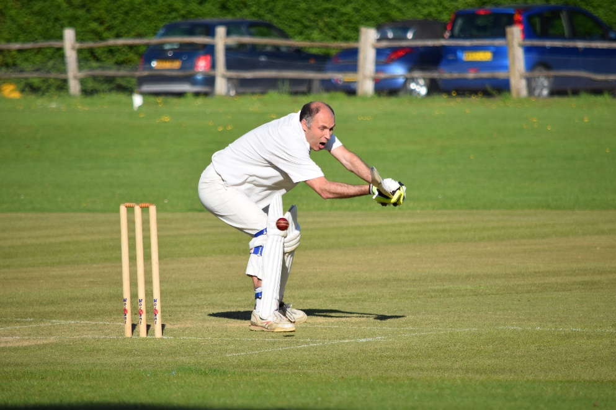
Will Cockerell reaches out

