Bushmen versus Victoria & Albert Museum
Saturday 29th April 2017
35 Overs game
Toss: V&A who batted

V&A
- L Nieboer lbw N Norman-Butler 45
- N Emley c E Faulks b M Cockerell 36
- S Julka b N Norman-Butler 39
- C Mounsey-Thear c Z Butt b E Faulks 40
- D de Caires not out 12
- T Bird c L Jones b N Norman-Butler 2
- N Pritchard-Gordon b L Jones 10
- C Jonkers not out 1
- N Bird )
- T Pritchard-Gordon ) did not bat
- D Simpson )
Extras (nb0, w9, b5, lb4) 18
TOTAL (35 overs) 208 for 6
1-81, 2-121, 3-166, 4-180, 5-188, 6-207
O M R W
- Z Butt 7 0 30 0
- C Jeavons 7 1 20 0
- L Jones 7 1 34 1
- N Norman-Butler 7 0 35 3
- M Cockerell 4 0 35 1
- E Faulks 3 0 37 1

Bushmen
- L Jones c Emley b de Caires 0
- N Norman-Butler c Jonkers b Simpson 27
- E Faulks c Emley b T P-Brown 7
- Z Butt c&b b T P-Brown 0
- R Fanner b Julka 21
- J Soomro run out 0
- J Whitehead c Nieboer b Simpson 2
- M Cockerell b de Caires 0
- T Walters not out 13
- C Jeavons not out 0
- A Popperwell did not bat
Extras (nb2, w4, b3, lb0) 9
TOTAL (35 overs) 80 for 8
1-9, 2-31, 3-31, 4-39, 5-41, 6-51, 7-55, 8 not recorded
O M R W
- C Jonkers 7 2 12 0
- D de Caires 7 2 8 1
- T Pritchard-Brown 7 1 12 2
- D Simpson 7 1 25 2
- S Julka 4 0 12 2
- L Nieboer 2 0 4 0
- C. Mounsey-Thear 1 0 5 0

V&A victory by 128 runs
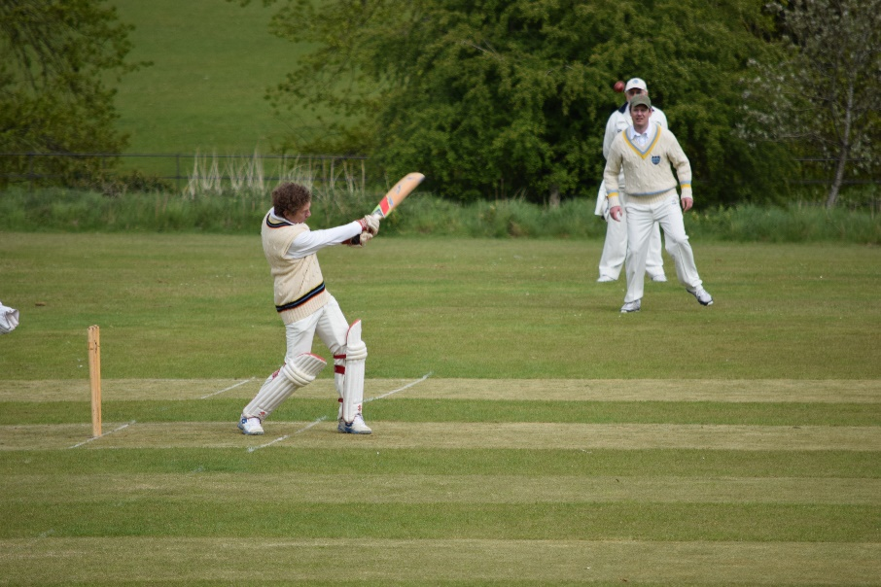
Edward Faulks strikes out

