Bushmen versus Sonning
Sunday 7th May 2017
Time game
Toss: Bushmen who batted
Bushmen
- G Dabby not out 103
- J Whitehead b Penhale 11
- Z Butt c N Ray b Said 28
- J Soomro b F Griffiths 17
- H Owens not out 15
- T Walters )
- D Morley )
- P Assegai ) did not bat
- M Cockerell )
- C Jeavons )
- A Popperwell )
Extras (nb3, w8, b10, lb9) 30
TOTAL (43 overs) 204 for 3 declared
1-43, 2-85, 3-151
O M R W
- E Richardson 8 1 33 0
- K Naha 6 2 24 0
- S Naqi 10 2 33 1
- K Penhale 6 1 16 1
- S Simmons 4 0 20 0
- M Longridge 4 0 30 0
- F Griffith 5 0 29 1

Sonning
- Travers c Soomro b G Dabby 40
- S Simmons b P Assegai 0
- K Naha b Z Butt 60
- S Dave b H Owens 2
- K Penhale b Z Butt 28
- B Travers b Z Butt 0
- N Ray b Z Butt 32
- F Griffith b Z Butt 2
- S Naqi b Z Butt 0
- E Richardson not out 16
- M Longridge not out 1
Extras (nb3, w8, b12, lb0) 23
TOTAL (38 overs) 204 for 9
1-2, 2-74, 3-82, 4-146, 5-146, 6-169, 7-171, 8-183, 9th not recorded
O M R W
- C Jeavons 7 2 21 0
- P Assegai 8 0 63 1
- H Owens 10 2 37 1
- G Dabby 5 0 31 1
- Z Butt 8 0 42 6

Draw with scores level
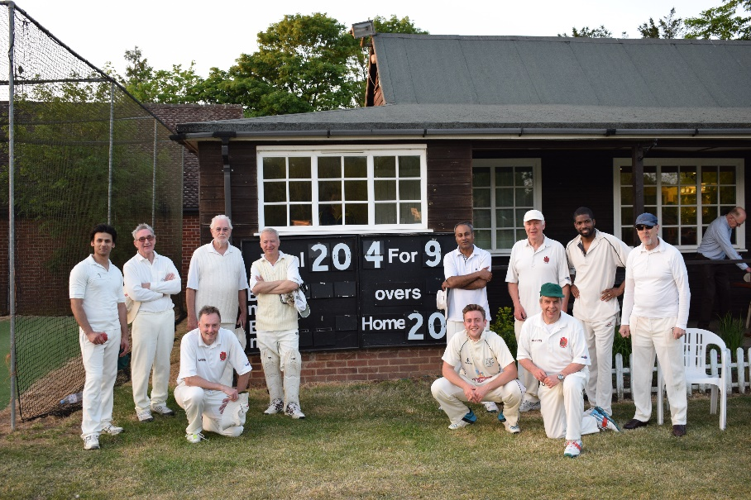
Our brave lads

