Bushmen versus Newdigate
Sunday 23rd April 2017
Time game
Toss: Bushmen who batted

The Bushmen
- *J Whitehead lbw b C Irvine 15
- S Marcus b J Westwood 0
- Z Butt lbw b J Westwood 11
- G Dabby lbw b Ruky 48
- M Cockerell b Ruky 11
- J Soomro b Ruky 14
- †T Roles not out 25
- P Assegai b W Bowley 4
- C Jeavons not out 0
- A Popperwell ) did not bat
- J Zelkowicz )
Extras (nb9, w3, b18, b11, lb3) 41
TOTAL (42 overs) 171 for 7 declared
1-11, 2-29, 3-50, 4-95, 5-154, 6-159, 7-167
O M R W
- J Westwood 5 0 3 2
- Dubruys 6 4 12 0
- P Westwood 6 2 13 0
- C Irvine 4 3 5 1
- Wood 4 1 11 0
- Bowley 7 0 48 0
- Ruky 7 1 26 3
- W Bowley 3 0 13 1

Newdigate
- W Bowley c Roles b M Cockerell 76
- J Bowley lbw b Z Butt 26
- J Wareham not out 53
- G Wood not out 2

Extras (nb0, w6, b9, lb2) 17
TOTAL (36.3 overs) 175 for 2
1-77, 2-146
O M R W
- P Assegai 7.3 0 43 0
- C Jeavons 6 1 33 0
- Z Butt 6 0 29 1
- G Dabby 4 0 32 0
- M Cockerell 3 0 31 1

Newdigate victory by 8 wickets
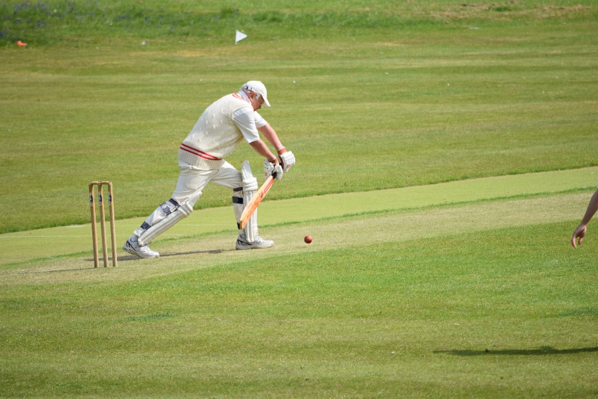
Michael Cockerell defends

