Bushmen versus Newdigate
Sunday 10th July 2016
Time game
Toss: Newdigate who fielded

The Bushmen
- †J Whitehead b R Flower 9
- L Jones b I Kehl 44
- S Marcus b B Haynes 24
- *W Jones b A Kehl 30
- H Owens c A Meades b A Kehl 12
- J Soomro b A Moon 0
- T Walters c A Kehl b C Moon 9
- M Cockerell not out 9
- A Popperwell not out 4
- C Jeavons ) did not bat
- R Heller )
Extras (nb5, w3, b27, lb3) 38
TOTAL (46 overs) 179 for 6 declared
1-23, 2-72, 3-94, 4-136, 5-137, 6-172
O M R W
- L Flower 7.3 2 18 1
- C Moon 10 2 33 1
- I Kehl 9 1 29 1
- B Haynes 9 1 45 1
- A Moon 6.3 1 17 1
- A Kehl 4 1 12 2

A Moon’s last over completed by L Flower after injury to his knee.
Newdigate
- M Rance b L Jones 28
- A Kehl b C Jeavons 54
- L O’Brien b W Jones 8
- S Capel b H Owens 21
- S Kehl c W Jones b C Jeavons 0
- A Meades not out 22
- A Moon b C Jeavons 1
- G Haynes c J Whitehead b C Jeavons 0
- R Flower b C Jeavons 18
- I Kehl not out 0
- C Moon did not bat
Extras (nb0, w13, b7, lb7) 27
TOTAL (36.3 overs) 180 for 8
1-59, 2-89, 3-117, 4-123, 5-134, 6-139, 7-139, 8-177
O M R W
- S Marcus 3 0 27 0
- L Jones 7 0 34 1
- W Jones 6.3 0 39 1
- C Jeavons 12 1 45 5
- H Owens 8 1 19 1

Newdigate victory by 2 wickets
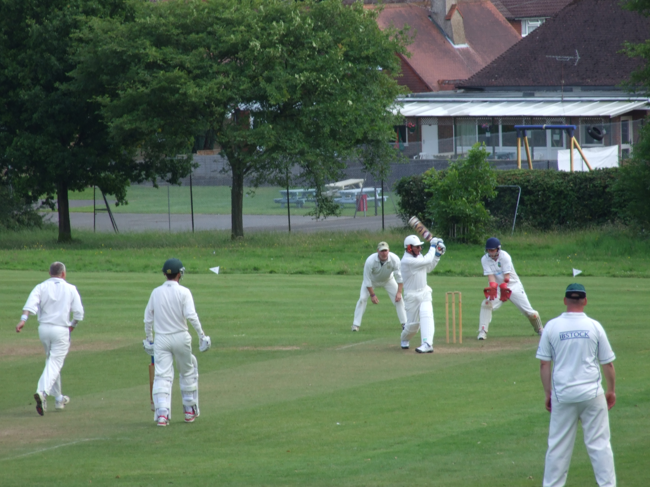
Howard Owens pulls to leg

