Bushmen versus Kirdford
Sunday 9th July 2017
Time game
Toss: Kirdford who fielded
Bushmen
- J Whitehead b J Smyth 30
- R Fanner c? b M Eustace 6
- C Ancil c? b P Haywood 40
- D Morley c wk b J Smyth 8
- H Owens not out 18
- S Crossley b P Sheppard 9
- J Soomro not out 1
- R Heller )
- M Cockerell ) did not bat
- C Jeavons )
- A Popperwell )
Extras (nb8, w26, b10, lb2) 46
TOTAL (38 overs) 159 for 5 declared
1-43, 2-107, 3-128, 4-128, 5-157
O M R W
- J Lywood 8 0 44 0
- J Smyth 11 1 42 2
- M Eustace 5 0 9 1
- P Sheppard 8 0 33 1
- P Haywood 6 0 18 1

Kirdford
- B Jeffery b C Ancil 4
- Charman b C Ancil 7
- Fletcher st D Morley b C Jeavons 8
- Sheppard b C Jeavons 0
- Haywood not out 63
- Lywood c D Morley b C Jeavons 0
- Mane b C Jeavons 0
- Smyth b C Jeavons 0
- C Slater c Whitehead b C Jeavons 0
- Eustace c R Fanner b J Soomro 0
- J Slater b M Cockerell 0
Extras (nb3, w3, b1, lb0) 7
TOTAL (27.1 overs) 91 all out
1-5, 2-21, 3-21, 4-27, others not recorded
O M R W
- C Jeavons 10 3 17 6
- C Ancil 8 2 25 2
- H Owens 3 0 10 0
- J Soomro 4 0 15 1
- M Cockerell 2.1 0 21 1

Bushmen victory by 68 runs
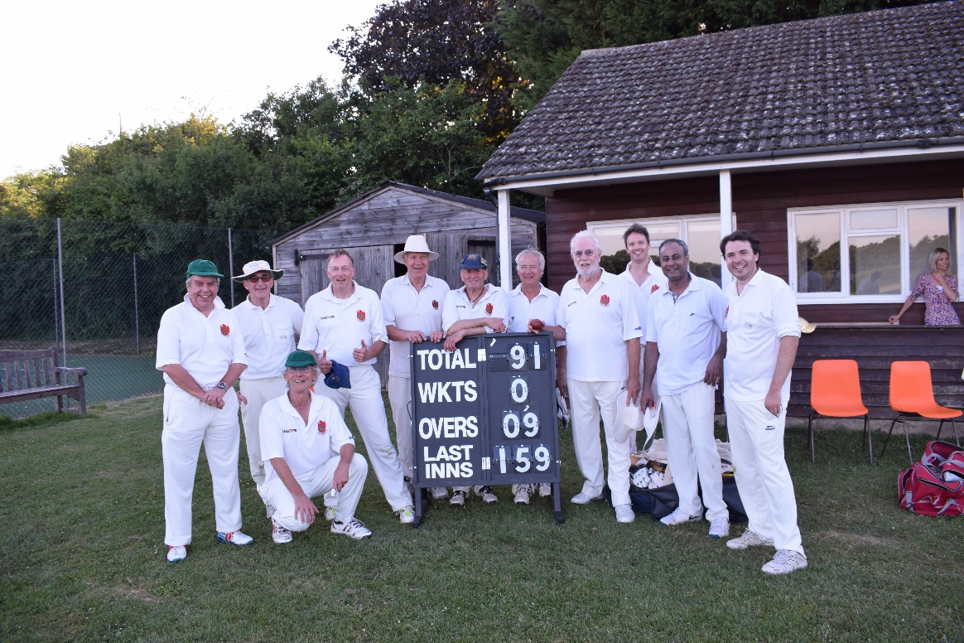
Our conquering heroes

