Bushmen versus Kirdford
Sunday 3rd July 2016
Time game
Toss: Bushmen who batted

The Bushmen
- W Jones b J Cox 6
- †J Whitehead c Johnson b J Smyth 7
- N Norman-Butler c Haywood b S Pett 94
- Z Butt c Charman? b J Rountree 16
- H Owens b P Haywood 15
- M Cockerell c Johnson b J Smyth 11
- S Crossley not out 1
- J Soomro )
- P Assegai ) did not bat
- *C Jeavons )
- A Popperwell )
Extras (nb5, w17, b14, lb2) 38
TOTAL (42.5 overs) 188 for 6 declared
1-16, 2-53, 3-95, 4-142, 5-186, 6-188
O M R W
- J Cox 12 4 23 1
- S Pett 9 1 9 1
- J Smyth 6 0 35 2
- J Rountree 7 0 40 1
- P Haywood 6 1 42 1
- G Fletcher 1 0 11 0
- B Jeffery 3 0 12 0

Nick Norman-Butler hit five sixes

Kirdford
- B Jeffery c Whitehead b W Jones 1
- S Johnson c Whitehead b P Assegai 0
- J Hickie b C Jeavons 9
- C Charman b P Assegai 0
- A Mans b W Jones 0
- G Fletcher b P Assegai 38
- J Cox b Norman-Butler 26
- J Rountree c Whitehead b A Popperwell 19
- P Haywood not out 0
- J Smyth b P Assegai 3
- S Pett b P Assegai 0
Extras (nb0, w7, b14, lb0) 21
TOTAL (38 overs) 123 all out
1-2, 2-3, 3-3, 4-10, others not recorded
O M R W
- W Jones 9 5 6 2
- P Assegai 9 3 13 5
- C Jeavons 10 0 33 1
- H Owens 3 0 8 0
- A Popperwell 3 0 32 1
- N Norman-Butler 3 0 5 1
- Z Butt 1 0 4 0

Bushmen victory by 65 runs
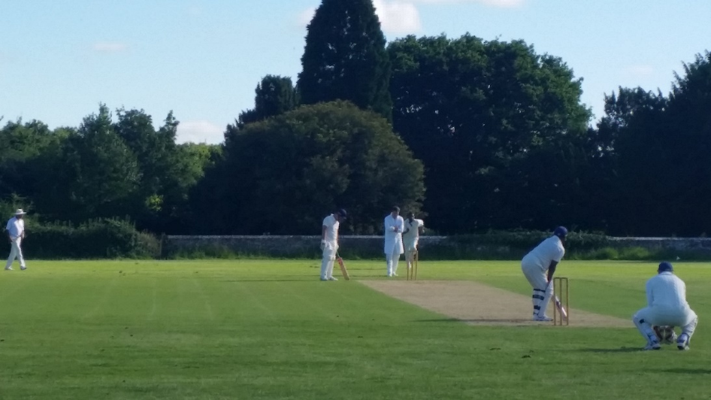
Pianki charges in on his way to 5 for 13

