Bushmen versus Fernhurst
Sunday 14th May 2017
Time game
Toss: Bushmen who batted
Bushmen
- L Jones c J Meier b S Vigar 5
- J Whitehead b B Gourlay 2
- W Jones b R Raymond 53
- T Roles c Gourlay b J Unwin 17
- D Morley c J Meier b R Raymond 16
- E Faulks c M Westley b S Vigar 18
- H Owens b M Langridge 0
- A Faulks b Brockwell 33
- J Fawcett not out 1
- C Jeavons not out 4
- A Popperwell did not bat
Extras (nb12, w11, b7, lb1) 31
TOTAL (38 overs) 181 for 8 declared
1-10, 2-16, 3-88, 4-101, 5-120, 6-122, 7-165, 8-174
O M R W
- S Vigar 6 0 24 2
- M Langridge 11 3 27 1
- B Gourlay 3 0 18 1
- R Unwin 4 0 22 0
- Brockwell 7 1 30 1
- J Unwin 3 0 14 1
- R Raymond 4 0 33 2

Fernhurst
- T Freeman b W Jones 13
- M Field c A Faulks b W Jones 8
- J Meier c A Faulks b C Jeavons 17
- M Westley b H Owens 41
- I Brockwell c A Faulks b C Jeavons 0
- J Unwin b C Jeavons 0
- R Raymond c D Morley b H Owens 4
- S Vigar c W Jones b J Fawcett 10
- M Langridge b H Owens 0
- R Unwin b J Fawcett 11
- B Gourlay not out 0
Extras (nb1, w1, b1, lb1) 4
TOTAL (28.2 overs) 107 all out
1-15, 2-38, 3-46, 4-47, 5-48, 6-69, 7-86, 8-86, 9-102, 10-107
O M R W
- W Jones 8 1 25 2
- C Jeavons 11 3 46 3
- H Owens 5 1 17 3
- L Jones 3 1 10 0
- J Fawcett 1.2 0 8 2

Bushmen victory by 74 runs
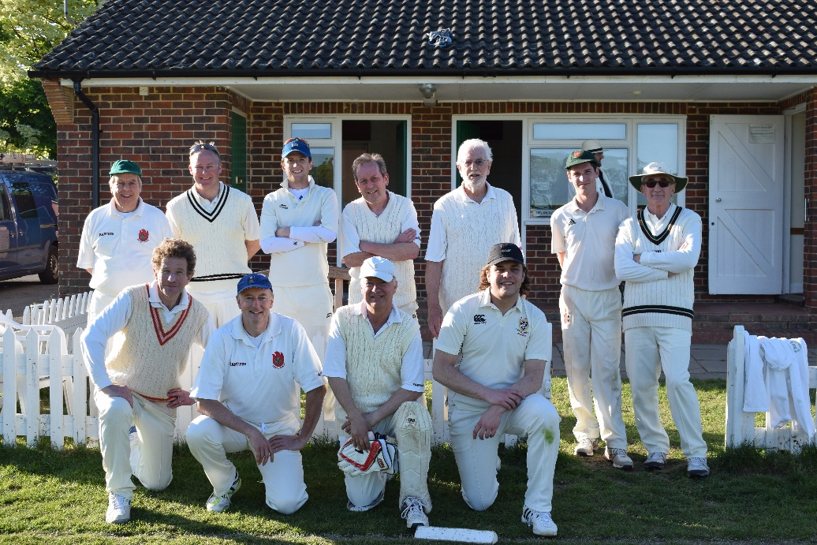
Our victorious team

