‘A vivid and highly readable guide to one of the great flash-points of the twenty-first century’
Gideon Rachman
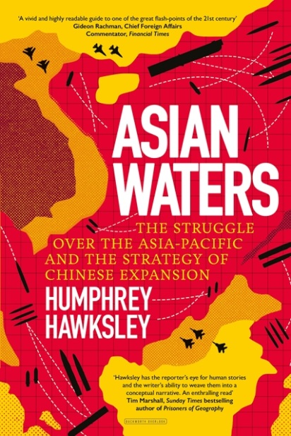
ASIAN WATERS
The Struggle Over the Asia-Pacific and the Strategy of Chinese Expansion
Humphrey Hawksley
Published 28th June
Royal HB | £20 | 304 pages ISBN 9780715652602
With 15 colour images and five maps

Author is a bestselling BBC foreign correspondent with decades of experience and is available for interview and written pieces
‘A readable and very well-informed guide to an area of real tension in the early decades of this century’ Chris Patten, last governor of Hong Kong, Chancellor of Oxford University

The first book to comprehensively break down the politics and tensions among the countries of the Asia- Pacific, by a foreign correspondent who has witnessed it first-hand.

Humphrey Hawksley has witnessed China’s rise from the front line. From being viewed as a murderous pariah dictatorship, to a world power with such determination and wealth that we talk in the same breath about the opportunities of trade and the risk of war, China’s influence has now spread throughout the Asia-Pacific, where great power interests collide amid the mistrust of unresolved conflicts and disputed territory. In the sphere of future global politics, surely no region will be as hotly contested. This is where authoritarian China is trying to re- write international law and challenge the democratic values of the United States and its allies.

The key flashpoint are clusters of remote reefs and islands from which China has created military bases, enabling it to control a 1.5 million square mile expanse of the South China Sea – a crucial world trading route that it now claims as its own. If China does get away with seizing and militarizing waters here, what will it do elsewhere in the world, and how far has it already reached? Bolstered by its South China Sea success, how are Beijing’s expansion plans impacting on India, Japan, South East Asia and even America and Europe itself? Does China need to be restrained? And if it is not, what will Russia, Iran or any government do when it sees that the international rule- book can so easily shredded and tossed aside?

No other Asian country can take on China alone. They look for protection from the United States, although it too may be ill equipped for the job at hand. Or could China be right when it argues that the US-led global system is tired, outdated and corrupt and needs to undergo massive reform or face extinction? With clear analysis from a renowned expert, Asian Waters has already received high praise including top-ranking government officials in Asia itself and from experts on both sides of the Atlantic.

‘Asian Waters deserves to be widely read and debated, all over the world’
Bill Emmott, author of The Fate of the West: The Battle to Save the World’s Most Successful Idea

MORE ADVANCE PRAISE FOR ASIAN WATERS
‘A timely, detailed and balanced examination of one of the crucial geo-political fault-lines of the twenty first century… accurately maps the complexity of the situation in the Asia-Pacific region, the choices open to policy-makers and a range of outcomes that could lead to cooperation, confrontation or conflict’
Admiral Chris Parry CBE, (Rtd.), author Super Highway: Sea Power in the 21st Century
‘With his solid, on-the-ground experience and incisive analysis derived from decades of first rate reportage, Humphrey Hawksley provides new ways of seeing and understanding the shifting balance of world power, a change of monumental significance for this century… a must-read’ James Clad, Director, Asian Security Programs at the American Foreign Policy Council, Former US deputy assistant secretary of defence for Asia Pacific Security Affairs

‘Hawksley has long and rich experience of life in Asia, and has used this to inform this lucid, lively account of the frontier of Chinese aspirations – the region in which it sits. It is here that the true face of Chinese power is being revealed: the waters of Asia. There are fewer better guides to this’ Kerry Brown, Director Lau China Institute, Kings College, London,
and author of China’s World: What Does China Want? and CEO, China: The Rise of Xi Jinping

‘Great power politics will define Asia’s future path. But in order to see what may lie ahead, it is critical to understand the people, the personalities, and the psychologies that drive the decision-making processes. Hawksley’s ability to do just that is second to none’ Shihoko Goto, North East Asia Program, Wilson Center

‘Hawksley masterfully pulls back the layers of history, old maps, and national pride that form the backdrop to one of Asia's most dangerous flash points, the South China Sea. Hawksley concludes with insightful suggestions about how China and the United States might learn to live together and what the disastrous stakes are for the globe if they clash’
Murray Hiebert, South East Asia Program. Center for Strategic and International Studies

ADVANCE PRAISE FROM ASIA
‘Hawksley focuses his immense skills at forensic political analysis to dissect twenty first century Asia’s
latest trouble spot. A fascinating read’
Hardeep Puri, Indian Minister for Housing and Urban Affairs, former Indian ambassador to the United Nations

‘Hawksley's writing style is accessible even when his subject grows more complex, ranging from
geographic diversity to narration about history and politics. Whether it is navigating on the political waves in East Asia, or exploring the great power status, the book offers a generous insight. Hawksley is a respected analyst, and he doesn't disappoint here’ Dr Wu Shicun, President of National Institute for South China Sea Studies, Hainan

‘Hawksley’s Asian Waters breathes life into the well-worn subject of the South China Sea by painting a vivid and comprehensive picture of Asia’s maritime security. It is truly an impressive piece of work that is sure to inspire and engage readers’ David Y L Lin, Representative, Taipei Representative Office in the UK, foreign minister 2012-2016
‘Asian Waters plays a critical role in defining India's importance in the evolving geo-strategic matrix. The author is an old India hand and Asian Waters contains a wealth of knowledge, skilfully portrayed in his thoughtful book. To understand the new Indo-Pacific region… a must read’ Major General Ashok K Mehta, Institute for Defence Studies and Analyses, India

ABOUT THE AUTHOR

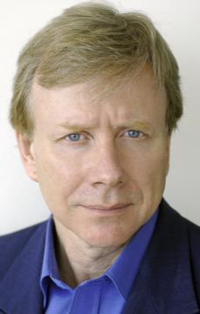
Humphrey Hawksley is a journalist and author who has been a foreign correspondent for the BBC since the early 1980s. He is the author of the ground-breaking Democracy Kills: What’s so good about the Vote, alongside the BBC documentary Danger: Democracy at Work in which he examined the risk of imposing democracy too hastily on some societies; and the acclaimed three-part ‘Future History’ series that explores hypothetical world conflict, aimed at bringing the complexities of global politics to a wider audience. His work has appeared widely in the international press including The Guardian, The Times, The Financial Times and The New York Times. He has lectured for institutions including Cambridge University, University College London and the London Business School. He is a regular panellist and moderator and has debated at Intelligence Squared and the Royal Geographical Society.

