THE BUSHMEN
...nec tamen consumebatur

DORSET WEEKEND

Saturday/Sunday, 2nd/3rd June 2018, 2.30 start both days

Book your accommodation now…

Thornford Hooke & Powerstock
1 Michael Cockerell 1 Michael Cockerell
2 Richard Heller 2 Richard Heller
3 Peter Herrmann 3 Peter Herrmann
4 Mowbray Jackson 4 Mowbray Jackson
5 *Clyde Jeavons 5 *Clyde Jeavons
6 Roger McCann 6 Roger McCann
7 Howard Owens 7 Howard Owens
8 Andy Popperwell 8 Andy Popperwell
9 †Gerry Tucker 9 †Gerry Tucker
10 10
11 11

Also available:
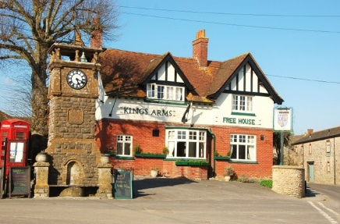
Thornford is south-west of Sherborne, and The King’s Arms, just beyond the cricket pitch, has returned to its original name after having been The Lime Tree for a while. Address: Pound Road, Thornford DT9 6QD. http://kings-arms-thornford.com/ There’s also a very good sandwich bar in Sherborne itself. There will possibly be a barbecue at the ground after the game. The ground’s postcode is DT9 6PH.

Peter Herrmann writes: Please be aware that the Thornford match is being played on their artificial wicket and appropriate footwear will be needed. There are no dinner arrangements at Thornford, although a large delivery of fish and chips or curry from Sherborne has been offered, should we be interested. I said we would decide on the day.
The King’s Arms in Thornford is open for Saturday lunch. I am told it is advisable to book: 01935 872294. Trip Advisor has some reviews.

The Hooke and Powerstock match is further south. The cricket ground is 3 or 4 miles east of the main Beaminster - Bridport road (A3066). The ground is almost in the village of Powerstock, so don’t look for it in Hooke. If you have an OS map, sheet 194, the reference is something like 953520 and you might need a compass to find it. There is no obvious signpost. The pitch is fairly indistinguishable from the rest of the field. It is very near Nettlecombe railway station, or what remains of it, and just off the road which crosses the railway.

The H&P secretary’s directions run thus:
From Beaminster leave on the main road towards Bridport. After passing through Melplash you will see a left-hand turn to a minor road marked West Milton/Powerstock. Go down this lane for approximately 2 miles until you reach a T-junction. Turn left here for West Milton/Powerstock. Pass through West Milton and before you reach Powerstock you will come to a crossroads in a dip. Go straight over here, past the Marquis of Lorne (half a mile on left) and continue for a further 200 yards to a T-junction. Turn left and the pitch is about 150 yards on the left, through a gate...

The Marquis of Lorne pub is a short distance from the ground and its postcode is DT6 3SY. http://www.themarquisoflorne.co.uk/ The Three Horseshoes also does good food: http://threeshoesdorset.co.uk/

Accommodation
You’ll need to find yourself accommodation for at least the Saturday night. Plenty of possibilities, but don’t leave it too late!.

Telephone: Captain John Whitehead 07771 761 466 mobile
email: john@whitehead.com

Team Sec: Andy Popperwell 020 8989 4436 home
07930 405 918 mobile
email andypop@btinternet.com

Match Sec: Peter Herrmann 020 8653 9909
email: thepeterherrmann@hotmail.com

